Vanier College

Computer Science Technology Program

Rocket Factory Game

GUI Application

**User Guide**

Meerab Khan (2388387), Jacob Magera

420‐331‐VA: Application Development (Sec‐02)

Teacher: Syed Naseem Afzal

Thursday, May 15, 2025

Table of Contents

Introduction: 3

Interactive Features: 3

Graphical User Interface: 3

Basic UI: 4

Application Features: 4

Exception Handling: 5

Number Display Combobox: 6

Music Toggle: 7

Achievements: 7

Rocket Enhancement switch: 8

Factory Improvement switch 9

Special Items Meteor Shower 10

Power Ups 11

Language Switch 11

GitHub: 14

Sources: 15

# 

# Introduction:

Our clicker game application, named “Rocket Factory”, is a GUI-based game application that aims to entertain players and provide a sense of fun and accomplishment as they progress through the game. It will also allow the user to choose between an active (via clicking and upgrades) or passive playstyle (via automatic earning points with helpers); This user’s manual will provide a detailed explanation of all features included in this game application.

# Interactive Features:

Clicker games have gained vast popularity due to their simple yet remarkably engaging mechanics. Many players enjoy the experience of improvement and victory these games provide. However, most clicker games generally follow the same patterns of incremental without offering much diversity in approach. Some of the major features of these applications include:

* A clickable Rocket Launch Button that produces points per interaction.
* A Dynamic Progress Tracker that updates the user’s points and clicks in real time.
* A Restart button to restart the game without having to run the application in IDE again.
* The Rocket Enhancement upgrade which switches the rocket image and increases the number of points.
* The Factory Improvement changes the form background after purchasing it with points.
* Power Ups increases most points with different titles.
* Special Items can create a background meteor shower for a limited amount of time and increase points.
* Various types of helpers increase points when the user is idle there is inflation for their price also after each purchase.
* Start button starts the game.
* Play button that has a moving range enables all features to start playing after clicking it.
* Settings button lets you view the settings form.
* On and Off radio buttons for music in settings page.
* The different achievements label lets you view the different upgrades purchased by the player shown by the color change.
* The number format Combo box lets you switch the points’ format into an engineer, scientific, or spoken notation.

# 

# Graphical User Interface:

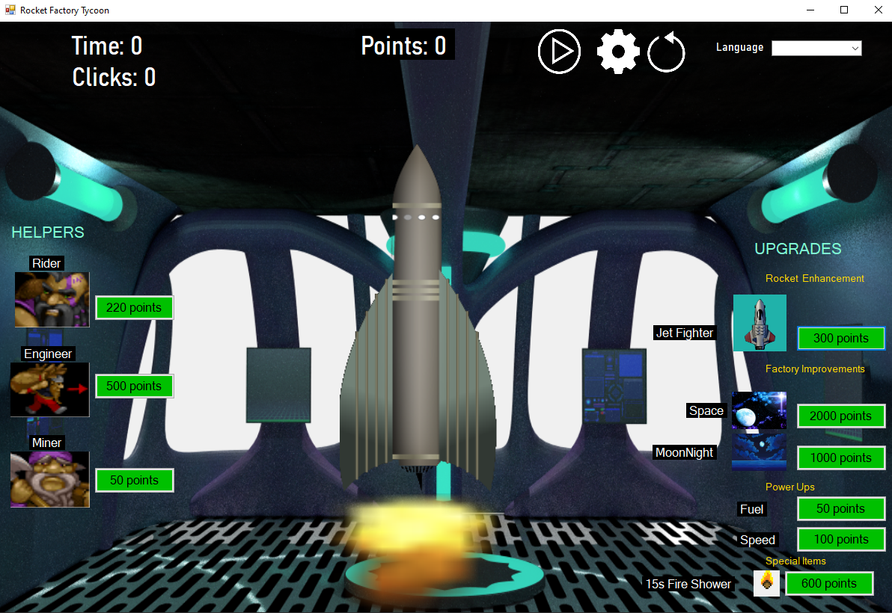

# 

# Basic UI:

This application is programmed using the C# language and comes with a very simple user interface and has an animated design. Additionally, when the user gets in the game, a welcome message is accompanied by the start button that lets the user enter the game. We can also see the time dynamically displaying the time, after the user starts clicking the rocket. There is a language Combo box to switch between languages. The shown event lets the user display the start form before the main rocket form.

# Application Features:

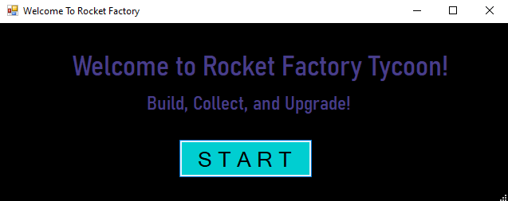

The game does include a musical sound feature.

# 

# Exception Handling:

If the user clicks the x or - on start form and not start button the user cannot access the main form. After clicking the start button the user then sees a play button moving left and right and stops moving at a click. This button needs to be clicked, so that all buttons are enabled for the user to interact with.



If the user tries to purchase an item that costs above the number of points earned, it displays:

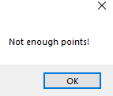

When the user clicks the restart button, a message asks user if he wants to restart game. If the user enters yes, the application restarts and if the user clicks no, then the game continues.

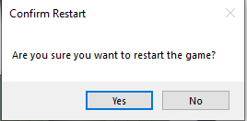

A message appears whenever the user successfully purchases.

Example:

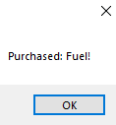

Since meteor shower has a time limit to 15 seconds, it shows at the end:

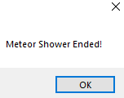

The main page gives you points based on the upgrades you have. Centered at the top of the page, there is a display which tracks the number of points that you have. On the right-hand side of the screen there is a section to purchase helpers which produce passive points and on the left-hand side there are upgrades that you can purchase. There is a gear icon in the top left corner to access settings.

# 

# Number Display Combobox:

To change the number display, navigate to the settings page and then click on this combobox:

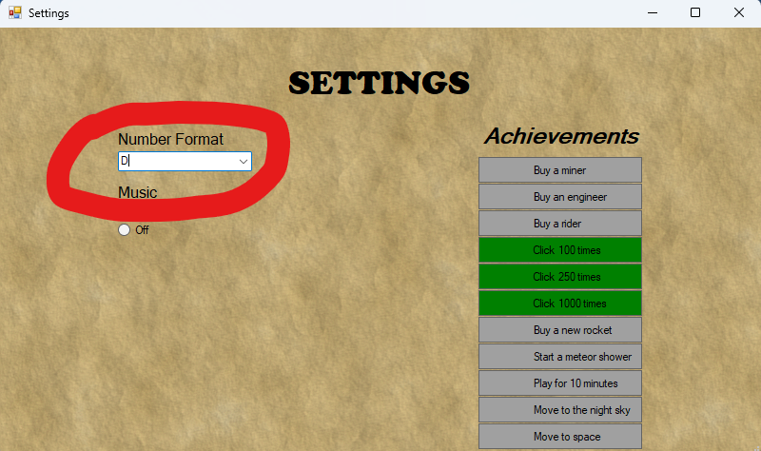

You will then be prompted by three options.

1. Spoken Notation 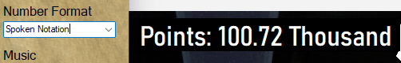
2. Scientific Notation

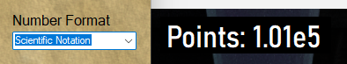

1. Engineering Notation

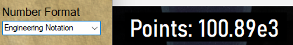

# Music Toggle:

To turn on/Off the music, navigate towards the settings page and use these radio buttons:

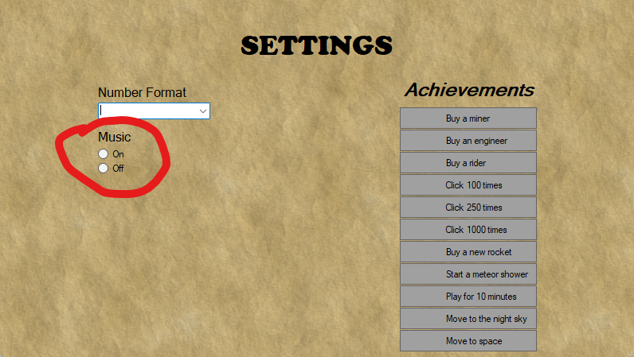

# 

# Achievements:

To access achievements, navigate to the settings page and look at this list:

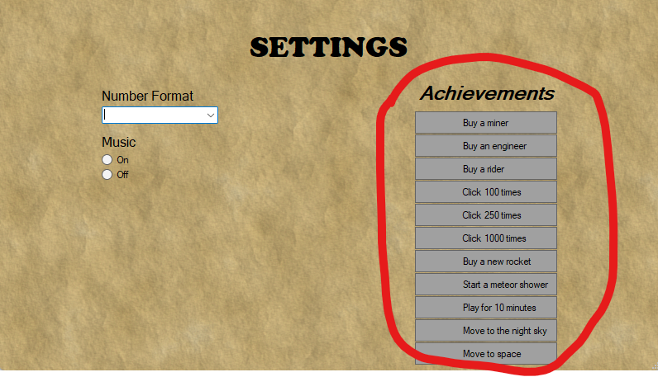

Any time you complete one of the tasks listed above, the corresponding grey box will turn green, indicating that it has been completed.

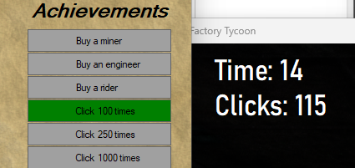

# Rocket Enhancement switch:

To switch between the rockets, the button near the rocket picture needs to be clicked, which will deduct points earned and increase the number of points by 50 at each purchase.

# 

# Factory Improvement switch

This feature is for users to have a nice view of the background or improve the look of the rocket placement. Again, the user needs to click the cost button to the right of the associated picture. This would lead to a change in the background.

# 

# 

# Special Items Meteor Shower

Currently, there is one meteor shower, it creates a rain of burning meteor in the background of the rocket for 15 seconds and increase points by 60 points.

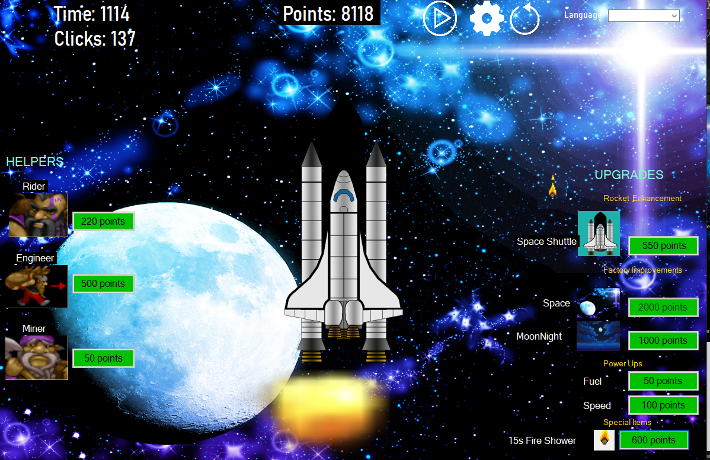

# 

# Power Ups

Power Ups have fuel, which increases points by 100 points and speed that increases by 200.

# Language Switch

-To switch between languages, player needs to select from combo box at the top right language of the interface.

-French

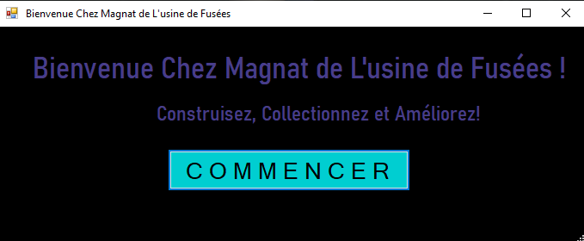

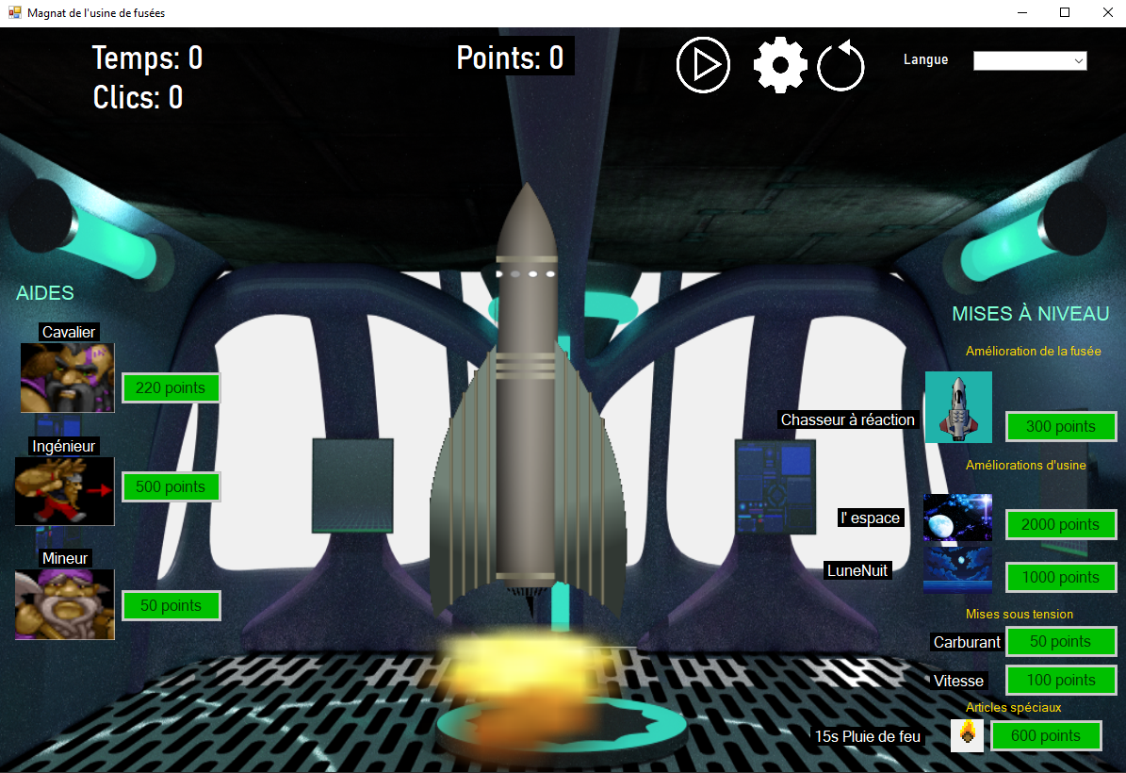

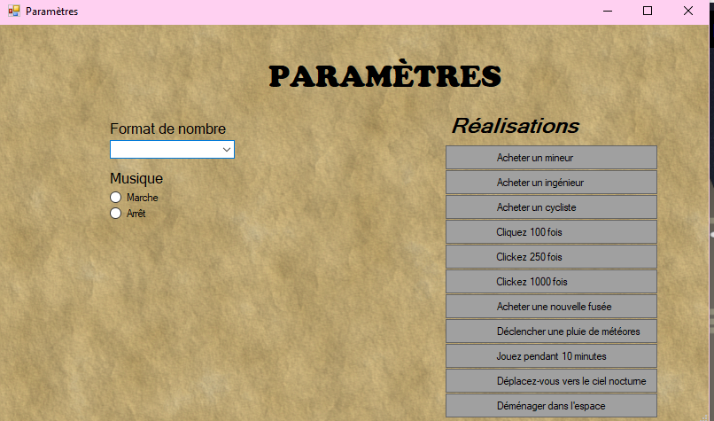

-Spanish

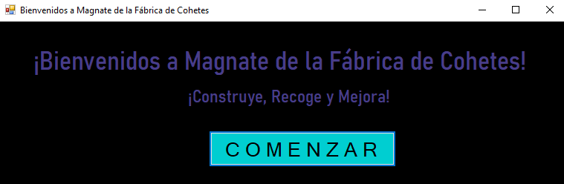

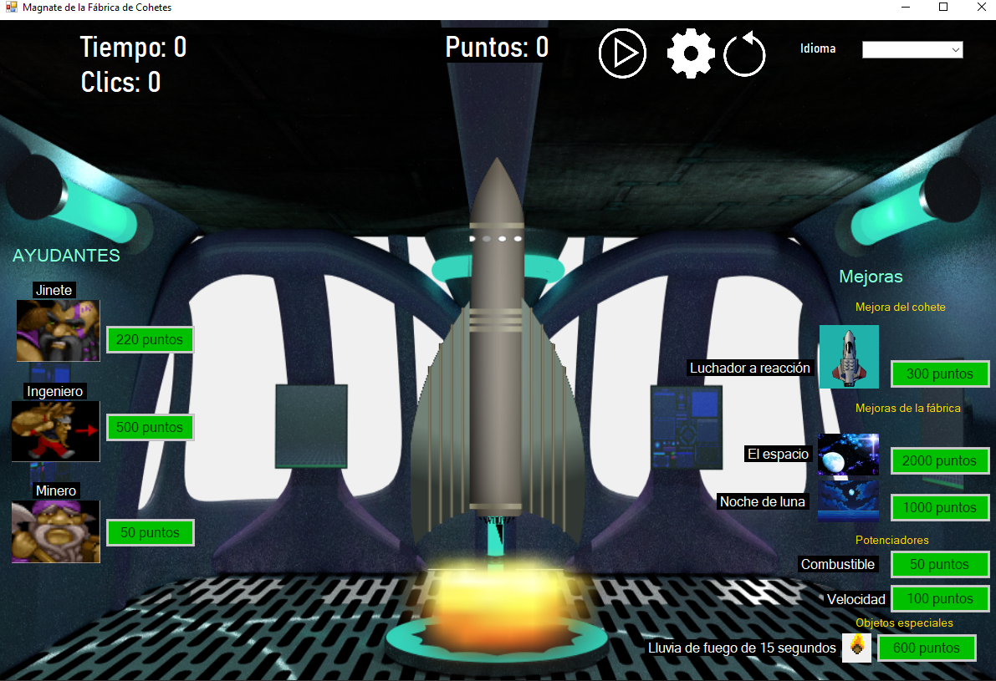

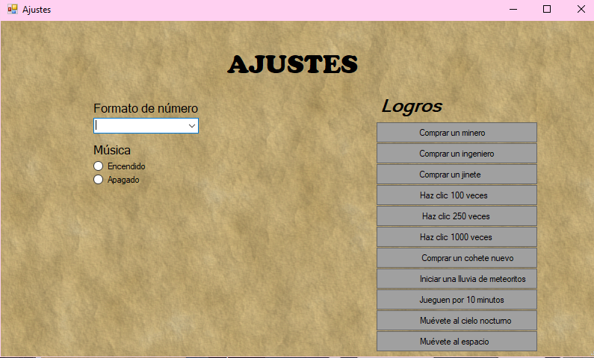

GitHub: <https://github.com/MEERABLK/rocket-factory-tycoon>

Sources:

-Background images

Courtesy of Centaur Spaceship Bridge by Tuomo Untinen, all included textures are under CC0 <https://opengameart.org/content/centaur-space-ship-bridge>

Courtesy of [CraftPix.net 2D Game Assets](https://opengameart.org/users/craftpixnet-2d-game-assets) under OGA-BY 3.0 <https://opengameart.org/content/moon-and-sea-pixel-art-background>

Courtesy of [Rawdanitsu](https://opengameart.org/users/rawdanitsu) under CC0 <https://opengameart.org/content/space-backgrounds-2>

Courtesy of [Lamoot](https://opengameart.org/users/lamoot) under CC-BY-3.0<https://opengameart.org/content/rpg-gui-construction-kit-v10>

-Rockets

Courtesy of [Conte Magnus](http://openclipart.org/user-detail/conte%20magnus)(Submitted by [qubodup](https://opengameart.org/users/qubodup)) under CC0 <https://opengameart.org/content/rockets>

Courtesy of [Rawdanitsu](https://opengameart.org/users/rawdanitsu) under CC0 <https://opengameart.org/content/space-rockets>

Courtesy of [MillionthVector](http://millionthvector.blogspot.de/)(Submitted by [Bonsaiheldin](https://opengameart.org/users/bonsaiheldin)) under CC-BY-3.0 <https://opengameart.org/content/animated-fighter-spaceship>

-Characters

Courtesy of [Jinn](http://jinndevil.tumblr.com/)(Submitted by [Andrettin](https://opengameart.org/users/andrettin)) under CC-BY-SA 3.0 <https://opengameart.org/content/dwarven-icons>

-Buttons

Courtesy of [Feidry](https://opengameart.org/users/feidry) under CC0 <https://opengameart.org/content/simple-ui-buttons>

-Music

Courtesy of [syncopika](https://opengameart.org/users/syncopika) under CC-BY-3.0 and GPL 2.0 <https://opengameart.org/content/blast-off-0>

-Canva Free Images

<https://www.canva.com/design/DAGm4VbYKTk/-SkDwfm4kISBFFbRYICPyQ/edit?ui=eyJBIjp7fX0>